Company ： JIANGSU LABONCE INSTRUMENT CO., LTD.
Address ：1F , 2F , NO.5 STANDARD FACTORY IN THE PIONEER PARK OF SMES, ECONOMIC DEVELOPMENT ZONE IN ZHENXING NORTH ROAD AND THE WEST OF WULING SOUTH ROAD , TAIZHOU CITY, JIANGSU PROVINCE, CHINA
Contact Person:Guston
Tel：+86-13811790181
Fax ：010-56545070
- mail ：export@labonce.com
Website：www.labonce.com

- Destination: | Shanghai port,China
- Payment: | T/T 100% In advance
- Delivery Date: | 10-25 workdays
- Packing: | Wooden box package
- Freight age: | Deliver to Shanghai port,China
- Guarantee: | 1 year
- After-sale Service: | 24 hours online service
⑻ Others:
Our company is specialized in the research &development and production of stability chambers. We adopted advanced Germany technology, reasonable structural design, and high-quality imported components, to supply stable, safe and reliable chambers.
1、Adopt the latest air duct system design, the temperature and humidity uniformity of different position inside the box is good；
2、Fully enclosed industrial compressor imported from Europe, high efficiency and low noise, ensure the long-term continuous operation of equipment；
3、European original imported temperature and humidity integrated sensor, with high sensitivity, low annual drift, direct detection of humidity without maintenance;
4、Imported temperature and humidity controller, quick induction, small system error；
5、Equipped with an alarm system that meets the requirements of GMP, a data collection system that meets the requirements of GMP, and a standard pin printer and SD card storage;
6、The liner material is full mirror stainless steel 304, easy to clean.

Description | Model | Unit | Quantity | FOB (USD) | Remark
Low-Temp Stability Chamber | Labonce-250RC | set | 1
Low-Temp Stability Chamber | Labonce-720RC | set | 1

Technical parameter：
Name | Low-Temp Stability Chamber
Model | Labonce-250RC | Labonce-720RC
Temperature Range | 5℃
Accuracy | ±0.5℃
Deviation | ±1.0℃
Temperature Control | The temperature inside won't over the standard when automation frost
Refrigeration System | Imported fully enclosed compressors
freezing medium | R134A
Controller | Original imported temperature digital display meter controller
Data Copy | Memory with USB flash disk
Dual protections | Independent overheat protection warning system
Ambient temp | ＋5～30℃
Interior material | Mirror surface Stainless steel 304
External material | Steel powder coated
Power source | AC 220V±10% 50Hz
Safety device | Compressor and blower overheat protection system, Over temperature protection, over pressure &overload protection for compressor
MAX power （kW） | 0.6 | 1.5
Capacity (L) | 250 | 720
Interior dimensions  W×D×H (mm) | 600×500×830 | 1200×490×1360
External dimensions  W×D×H(mm) | 780×880×1650 | 1385×895×1965
Packing dimensions W×D×H(mm) | 980×850×1770 | 1430×970×2100
Trays (standard) | 3 | 4
GW(kg) | 213 | 395

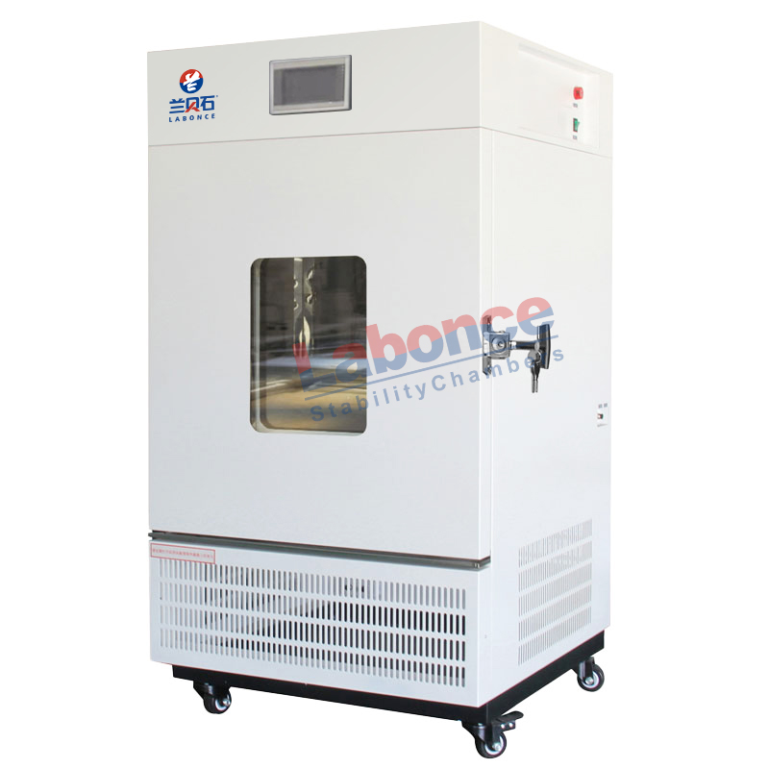

250BC

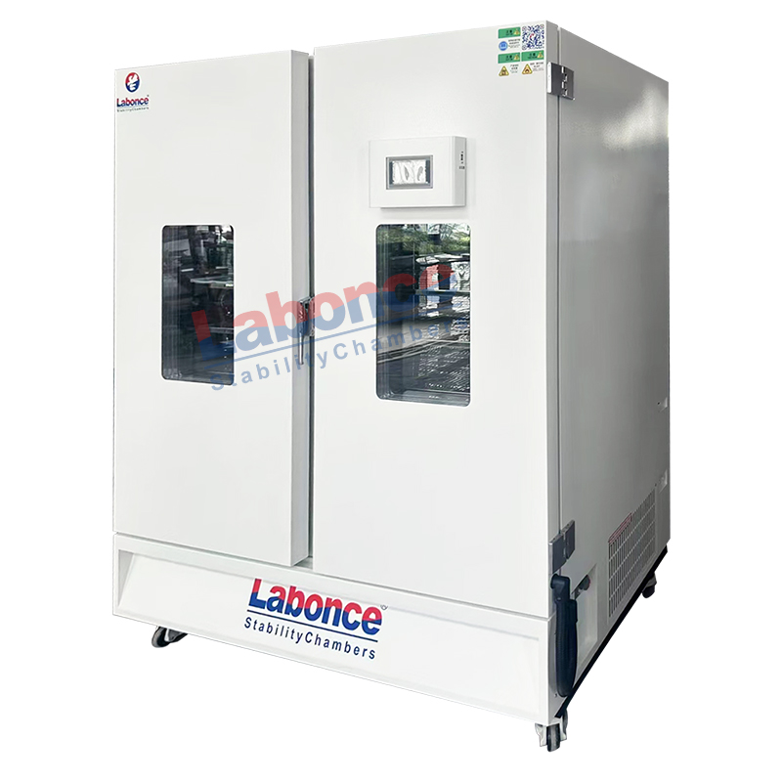

720RC

