Company ： JIANGSU LABONCE INSTRUMENT CO., LTD.
Address ：1F , 2F , NO.5 STANDARD FACTORY IN THE PIONEER PARK OF SMES, ECONOMIC DEVELOPMENT ZONE IN ZHENXING NORTH ROAD AND THE WEST OF WULING SOUTH ROAD , TAIZHOU CITY, JIANGSU PROVINCE, CHINA
Contact Person:Guston
Tel：+86-13811790181
Fax ：010-56545070
- mail ：export@labonce.com
Website：www.labonce.com

- Destination: | Shanghai port,China
- Payment: | T/T 100% In advance
- DeliveryDate: | 30-35 days
- Packing: | Wooden box package
- Freightage: | Deliver to Shanghai port,China
- Guarantee: | 1 year
- After-sale Service: | 24 hours online service
⑻ Others:
Our company is specialized in the research &development and production of stability chambers. We adopted advanced Germany technology, reasonable structural design, and high-quality imported components, to supply stable, safe and reliable chambers.
1、Adopt the latest air duct system design, the temperature and humidity uniformity of different position inside the box is good；
2、Fully enclosed industrial compressor imported from Europe, high efficiency and low noise, ensure the long-term continuous operation of equipment；
3、European original imported temperature and humidity integrated sensor, with high sensitivity, low annual drift, direct detection of humidity without maintenance;
4、Imported temperature and humidity controller, quick induction, small system error；
5、Equipped with an alarm system that meets the requirements of GMP, a data collection system that meets the requirements of GMP, and a standard pin printer and SD card storage;
6、The liner material is full mirror stainless steel 304, easy to clean.

Description | Model | Unit | Quantity | FOB Shanghai（USD） | FOB Total（USD） | Notes
Stability Chamber | Labonce-250FS | set | 1
Stability Chamber | Labonce-720FS | set | 1
Total：

Technical Parameter：

Name | Stability Chamber
Model | Labonce-250FS | Labonce-720FS
Temperature Range | 15～65℃
Uniformity | ±0.1℃
Fluctuation | ±0.2℃
Deviation | ±0.5℃
Humidity Range | 20～95%RH
Deviation | ±2%RH
Fluctuation | ±2%RH
Control Manner | Temperature and humidity balance Control
Refrigeration System | Imported industry compressor
Humidity Sensor | Imported humidity sensor
Controller | Imported Touch screen Temperature and humidity controller
Data Record | Micro Printer with needle type
Data Copy | Flash memory with SD Card
Test point | 25℃ 60%RH
Deviation | High&low boundary deviation alarm for temperature&humidity
Dual protections | Independent overheat protection warning system
Ambient temp | ＋5～35℃
Interior material | Mirror surface Stainless steel 304
External material | Steel powder coated
Water tank | External Water Tank
Power source | AC 220V±10% 50Hz
Dual door | Glass door inside
MAX power （kW） | 1.5 | 2.5
Capacity (L) | 250 | 750
Interior dimensions  W×D×H (mm) | 600×500×830 | 1200×490×1360
External dimensions  W×D×H(mm) | 780×880×1650 | 1390×900×1970
Packing dimensions  W×D×H(mm) | 980×850×1770 | 1420*970*2100
GW | 213 | 430
Shelf (standard) | 3 | 4

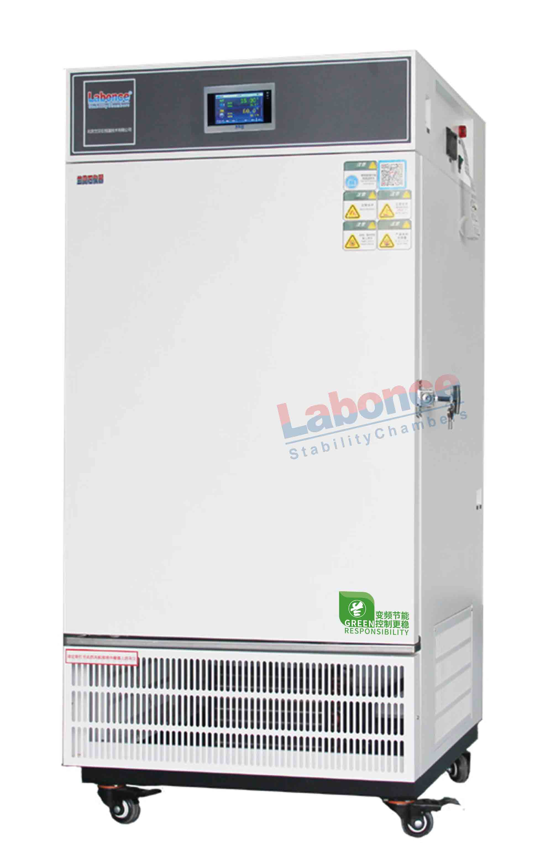

Labonce-250FS

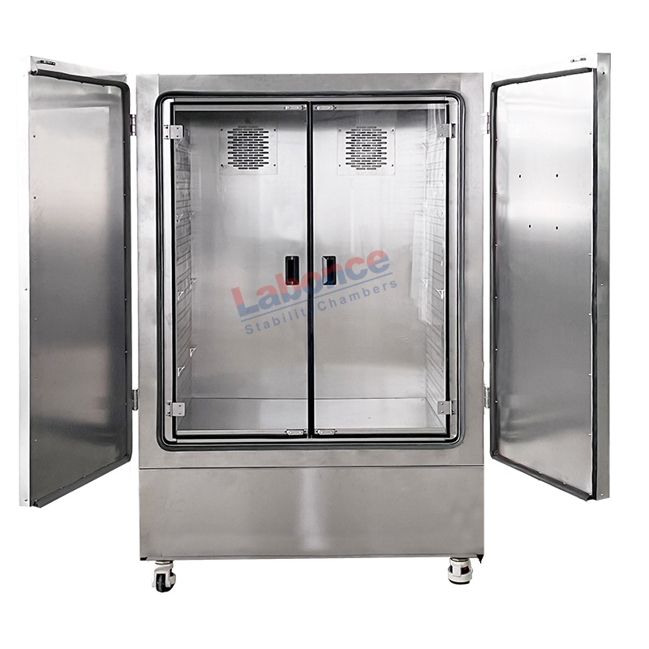
Labonce-720FS

