Company ： JIANGSU LABONCE INSTRUMENT CO., LTD.
Address ：1F , 2F , NO.5 STANDARD FACTORY IN THE PIONEER PARK OF SMES, ECONOMIC DEVELOPMENT ZONE IN ZHENXING NORTH ROAD AND THE WEST OF WULING SOUTH ROAD , TAIZHOU CITY, JIANGSU PROVINCE, CHINA
Contact Person:Guston
Tel：+86-010-56545023 +86-13811790181
Fax ：010-56545070
E-mail ：export@labonce.com
Website：www.labonce.com

- Destination: | China
- Payment: | T/T 100% in advance
- Delivery Date: | 20-25 workdays
- Packing: | Wooden box package
- Freight age: | Deliver to Shanghai port,China
- Guarantee: | 1 year.
- After-sale Service: | 24 hours online service
⑻ Others:
Our company is specialized in the research &development and production of stability chambers. We adopted advanced Germany technology, reasonable structural design, and high-quality imported components, to supply stable, safe and reliable chambers.
1、Adopt the latest air duct system design, the temperature uniformity of different position inside the box is good；
2、Fully enclosed industrial compressor imported from Europe, high efficiency and low noise, ensure the long-term continuous operation of equipment；
3、European original imported temperature integrated sensor, with high sensitivity, low annual drift, without maintenance;
4、Imported temperature controller, quick induction, small system error；
5、Equipped with an alarm system that meets the requirements of GMP, a data collection system that meets the requirements of GMP, and a standard pin printer and U-DISK storage;
6、The liner material is full mirror stainless steel 304, easy to clean.

Description | Model | Unit | Quantity | Discount Price（RMB） | Note
Storage Chamber | Labonce-250BC | set | 1 |  | Market price：
Storage Chamber | Labonce-400BC | set | 1
Storage Chamber | Labonce-500BC | set | 1
Storage Chamber | Labonce-800BC | set | 1
Storage Chamber | Labonce-1000BC | set | 1

Technical parameter：
Name | Storage Chamber
Model | Labonce-250BC | Labonce-400BC |  | Labonce-500BC |  | Labonce-800BC | Labonce-1000BC
Temperature Range | 2～14℃
Accuracy | ±1℃
Deviation | ±2.0℃
Temperature Control | The temperature inside won't over the standard when automation frost
Refrigeration System | Imported fully enclosed compressors
freezing medium | R134A
Controller | Original imported temperature digital display meter controller
Data Copy | Memory with USB flash disk
Dual protections | Independent overheat protection warning system
Ambient temp | ＋5～35℃
Interior material | Mirror surface Stainless steel 304
External material | Steel powder coated
Power source | AC 220V±10% 50Hz
Safety device | Compressor and blower overheat protection system, Over temperature protection, overpressure &overload protection for compressor
MAX power （kW） | 0.6 |  | 0.8 |  | 1.0 | 1.2 | 1.5
Capacity (L) | 250 |  | 400 |  | 500 | 800 | 1000
Interior dimensions  W×D×H (mm) | 600×500×830 |  | 600×700×950 |  | 680×680×1080 | 1200×490×1360 | 1400×510×1400
External dimensions  W×D×H(mm) | 780×880×1650 |  | 780×1060×1750 |  | 860×1050×1850 | 1385×895×1965 | 1615×925×1975
Packing dimensions W×D×H(mm) | 850×980×1770 |  | 840×1150×1920 |  | 930×1140×2050 | 1430×970×2100 | 1620×980×2150
Trays (standard) | 3 |  | 3 |  | 4 | 4 | 4
GW(kg) | 213 |  | 250 |  | 300 | 395 | 460

Catalog
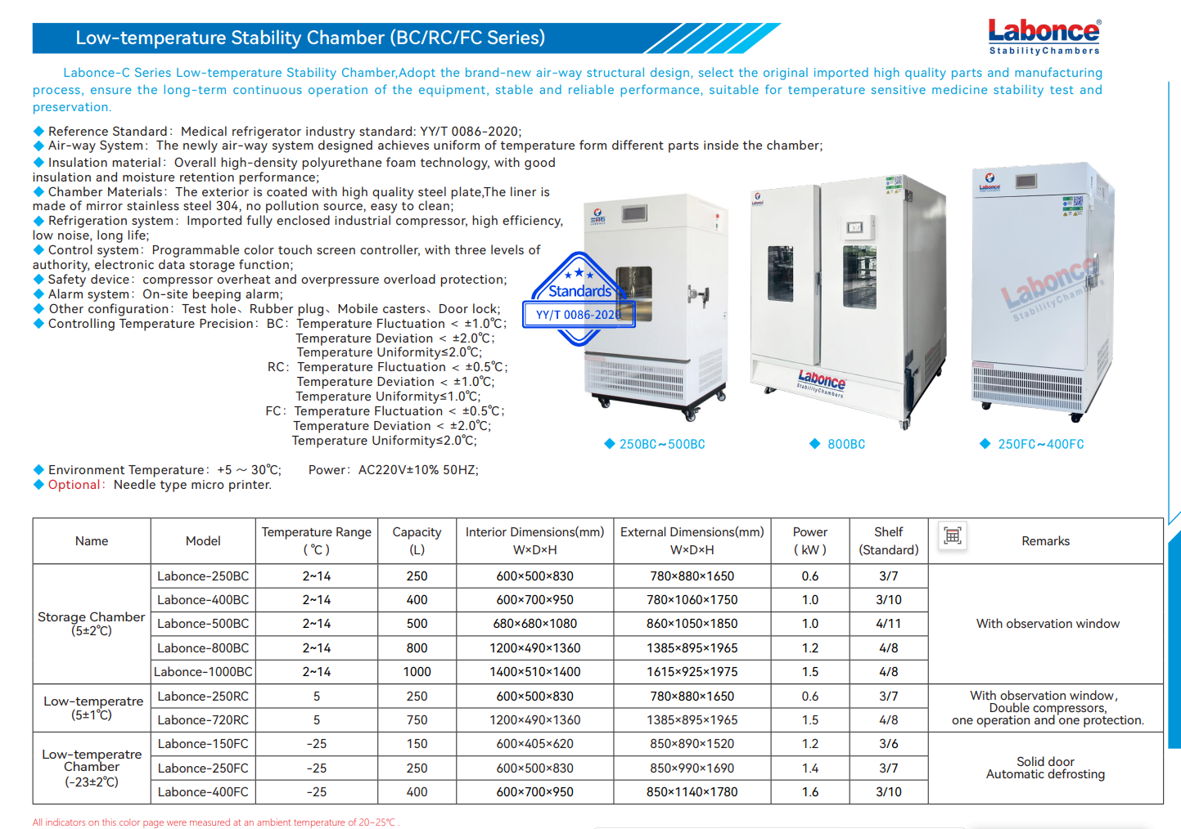
Equipment picture | 