Company ： JIANGSU LABONCE INSTRUMENT CO., LTD.
Address ：1F , 2F , NO.5 STANDARD FACTORY IN THE PIONEER PARK OF SMES, ECONOMIC DEVELOPMENT ZONE IN ZHENXING NORTH ROAD AND THE WEST OF WULING SOUTH ROAD , TAIZHOU CITY, JIANGSU PROVINCE, CHINA
Contact Person ：Cheney
Tel：+86-13811790181
Fax ：010-56545070
- mail ：export@labonce.com
Website：www.labonce.com

- Destination: | Shanghai Port,China
- Payment: | T/T 100% in advance
- Delivery Time: | 25 working days
- Packing: | Wooden box package
- Freightage: | Deliver to Shanghai Port,China
- Guarantee: | 1 year
- After-sale Service: | 24 hours Online service
⑻ Others:

The constant temperature & humidity chamber, environmental testing chamber is mainly used in testing the adaptability of electronics, electrical appliances, food, automobile, rubber and plastic, metal and other products, parts and materials in the high and low temperature alternating hot and humid environment when storage, transport and using.

Description | Model | Unit | Quantity | Discount price USD | Note
Constant temperature and Humidity chamber | Labonce-150CH-T | set | 1
Constant temperature and Humidity chamber | Labonce-250CH-T | set | 1
Constant temperature and Humidity chamber | Labonce-400CH-T | set | 1
Constant temperature and Humidity chamber | Labonce-500CH-T | set | 1
Total：

Name | Constant temperature and Humidity chamber
Model | Labonce-150CH-T | Labonce-250CH-T | Labonce-400CH-T | Labonce-500CH-T
Temperature Range | 15～60℃
Accuracy | ±0.5℃
Deviation | ±1.0℃
Temperature Uniformity | 2.0℃
Humidity Control | 20～95%RH
Humidity Fluctuation | ±3%RH
Humidity deviation | ±3%RH
Structure Design | Adopt the latest airduct system design achieves good uniform of temperature and humidity form different parts inside the chamber.
Chamber Material | The liner is made of mirror stainless steel 304
Refrigeration System | Imported fully enclosed compressors
Humidity System | Imported capacitive humidity sensor
Controller | programmable color touch screen controller with data storage function, data can be exported through USB flash drive
Ambient temp | ＋5～35℃
Power source | AC 220V±10% 50Hz
Safety device | Compressor overheat protection and overload protection、Fan overheating protection、Water scarcity protection
Dual protection | Equipped with double insurance dry fire protection system, equipped with independent overtemperature protection system, can automatically cut off the power supply;
Live Alarm: | Temperature and humidity upper and lower limit deviation alarm;Independent overtemperature protection alarm system.
Temperature Range | 15～60℃
Accuracy | ±0.5℃
MAX power （kW） | 1.2 | 1.5 | 2.0 | 2.2
Capacity (L) | 150 | 250 | 400 | 500
Interior dimensions  W×D×H (mm) | 600×405×620 | 600×500×830 | 600×700×950 | 680×680×1080
External dimensions  W×D×H(mm) | 780×830×1480 | 780×880×1650 | 780×1060×1750 | 860×1050×1850
Packing dimensions  W×D×H(mm) | 870*850*1570 | 980×850×1770 | 850x1080x1980 | 930×1140×2040
Trays (standard) | 3 | 3 | 3 | 4
GW(KG) | 185 | 213 | 250 | 300
Technical Parameter：

Catalog
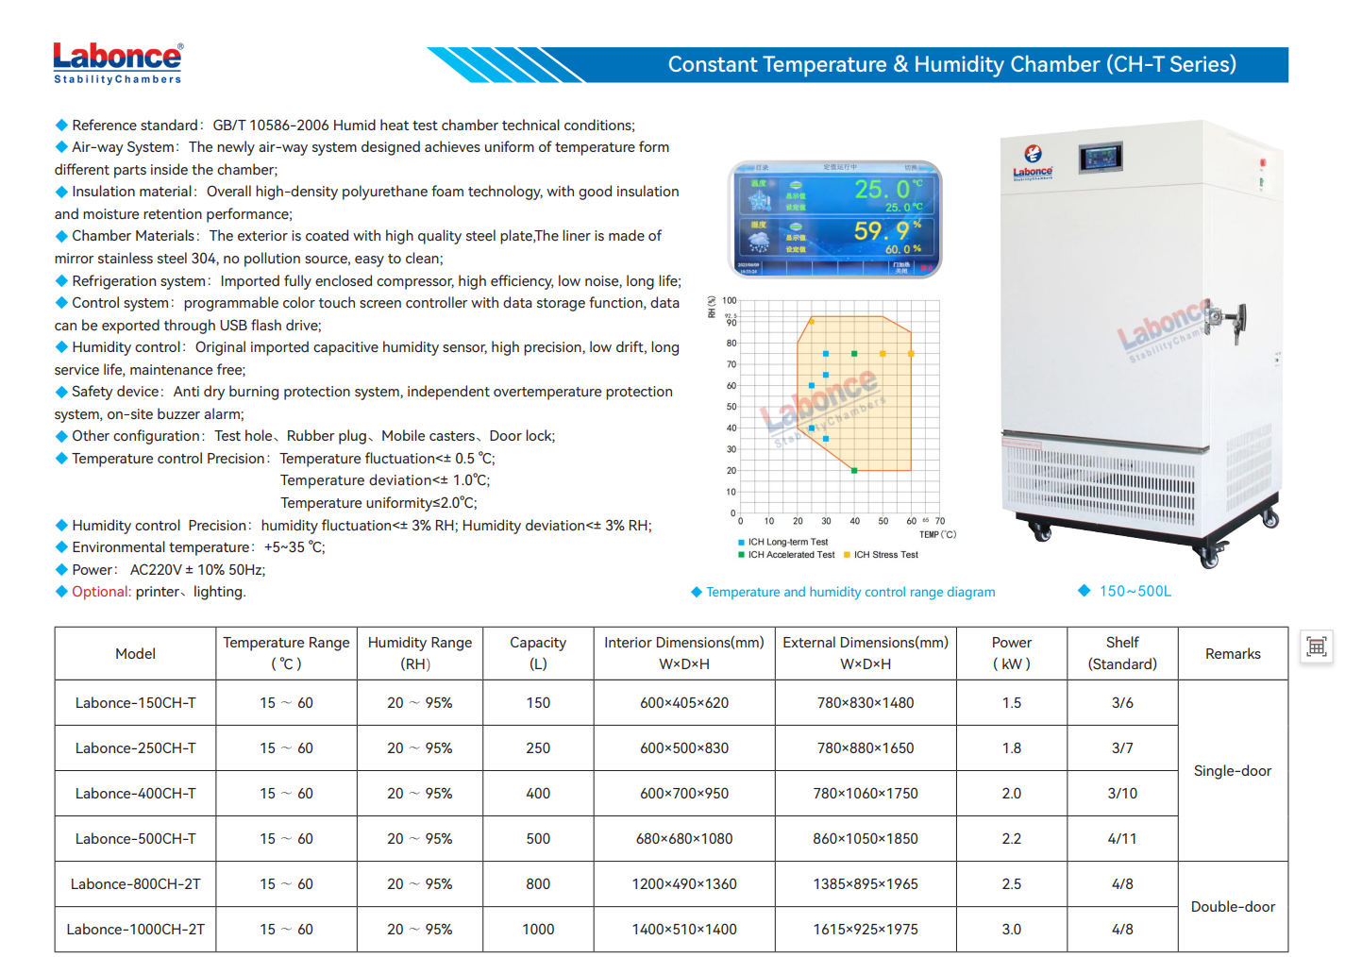
Equipment picture | 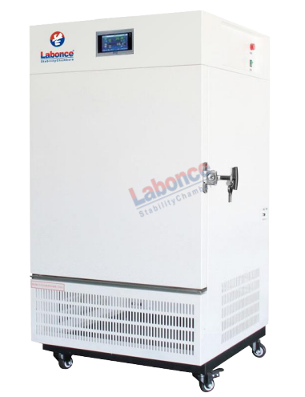
Temperature and humidity range diagram | 