Company ： JIANGSU LABONCE INSTRUMENT CO., LTD.
Address ：1F , 2F , NO.5 STANDARD FACTORY IN THE PIONEER PARK OF SMES, ECONOMIC DEVELOPMENT ZONE IN ZHENXING NORTH ROAD AND THE WEST OF WULING SOUTH ROAD , TAIZHOU CITY, JIANGSU PROVINCE, CHINA
Contact Person:Guston
Tel：+86-010-56545023 +86-13811790181
Fax ：010-56545070
E-mail ：export@labonce.com
Website：www.labonce.com

- Destination: | Within China
- Payment: | Negotiate
- DeliveryDate: | 25-30 workdays
- Packing: | Wooden box package
- Freightage: | Within China
- Guarantee: | 1 year
- After-sale Service: | 24 hours online service
⑻ Others:
Our company is specialized in the research &development and production of stability chambers. We adopted advanced Germany technology, reasonable structural design, and high-quality imported components, to supply stable, safe and reliable chambers.
1、Adopt the latest air duct system design, the temperature uniformity of different position inside the box is good；
2、Programmable color touch screen controller, high efficiency and low noise, ensure the long-term continuous operation of equipment；
3、European original imported temperature integrated sensor, with high sensitivity, low annual drift;
4、Imported temperature controller, quick induction, small system error；
5、Equipped with an alarm system that meets the requirements of GMP, a data collection system that meets the requirements of GMP, and a standard pin printer and USB disk storage;
6、The liner material is full mirror stainless steel 304, easy to clean.
Description | Model | Unit | Quantity | Total price（USD） | Notes
Biochemical Incubator | Labonce-150BI | set | 1
Biochemical Incubator | Labonce-250BI | set | 1
Biochemical Incubator | Labonce-400BI | set | 1
Biochemical Incubator | Labonce-500BI | set | 1
Total:
Technical Parameter：
Name | Biochemical Incubator
Model | Labonce-150BI | Labonce-250BI | Labonce-400BI | Labonce-500BI
Temperature Range | 0～60℃
Accuracy | ±0.5℃
Deviation | ±1.0℃
Control Manner | Temperature balance Control
Refrigeration System | Imported industry compressor
Temperature Sensor | PT100
Controller | programmable touch screen temperature controller (with three levels of authority)
Deviation Alarm | High&low boundary deviation alarm for temperature
Dual protections | Independent overheat protection warning system
Ambient temp | ＋5～35℃
Interior material | Mirror surface Stainless steel 304
External material | Steel powder coated
Power source | AC 220V±10% 50Hz
Safety device | Compressor and blower overheat protection system, Over temperature protection, overpressure &overload protection for compressor
Data Record | Configure needle type micro printer and electronic data storage function,support to use U disk to export the data
MAX power （kW） | 0.5 | 0.6 | 1.0 | 1.2
Capacity (L) | 150 | 250 | 400 | 500
Interior dimensions  W×D×H (mm) | 520×460×600 | 520×460×1050 | 600×700×950 | 680×680×1080
External dimensions  W×D×H(mm) | 640×700×1250 | 620×690×1650 | 780×1060×1750 | 860×1050×1850
Packing dimensions W×D×H(mm) | 740×800×1350 | 850×980×1770 | 840×1150×1920 | 930×1140×2050
Trays (standard) | 3 | 3 | 3 | 4

Catalog
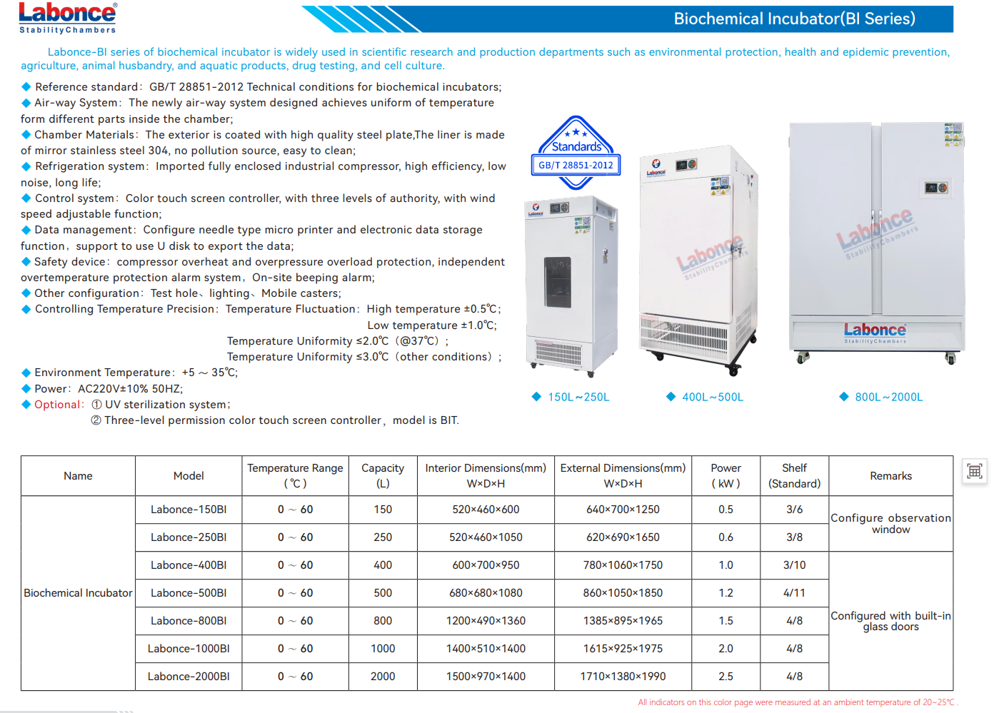

Equipment picture | 