Company ： JIANGSU LABONCE INSTRUMENT CO., LTD.
Address ：1F , 2F , NO.5 STANDARD FACTORY IN THE PIONEER PARK OF SMES, ECONOMIC DEVELOPMENT ZONE IN ZHENXING NORTH ROAD AND THE WEST OF WULING SOUTH ROAD , TAIZHOU CITY, JIANGSU PROVINCE, CHINA
Contact Person:Guston
Tel：+86-010-56545023 +86-13811790181
Fax ：010-56545070
E-mail ：export@labonce.com
Website：www.labonce.com

- Destination: | Within China
- Payment: | Negotiate
- Delivery Date: | 25-35 workdays
- Packing: | Wooden box package
- Freight age: | Within China
- Guarantee: | 1 year
- After-sale Service: | 24 hours online service
⑻ Others: | The quotation is valid until March 31 2025
Our company is specialized in the research &development and production of temperature chambers. We adopted advanced Germany technology, reasonable structural design, and high-quality imported components, to supply stable, safe and reliable chambers.
1、Adopt the latest air duct system design, the temperature and humidity uniformity of different position inside the chamber is good；
2、Fully enclosed industrial compressor imported from Europe, high efficiency and low noise, ensure the long-term continuous operation of equipment；
3、European original imported temperature sensor, with high sensitivity, low annual drift, direct detection of humidity without maintenance;
4、Special temperature controller, quick induction, small system error；
5、The liner material is full mirror stainless steel 304, easy to clean.

Description | Model | Unit | Qty | EXW price（USD） | Notes
High & low temperature and humidity chamber | Labonce-100JSC | set | 1
High & low temperature and humidity chamber | Labonce-250JSC | set | 1
High & low temperature and humidity chamber | Labonce-500JSC | set | 1
High & low temperature and humidity chamber | Labonce-1000JSC | set | 1
Total:

Technical Parameter：
Name | High & low temperature and humidity chamber
Model | Labonce-100JSC | Labonce-250JSC | Labonce-500JSC | Labonce-100JSC
Temperature Range | -60～150℃
Accuracy | ±0.5℃
Deviation | ±2.0℃
Humidity range | 20-98%RH
Humidity Fluctuation(RH) | ±3 %RH℃
Heating rate | 1~3℃/min
Cooling rate | 0.7~1℃/min
Refrigeration System | Imported industry compressor
Control system | programmable chromatic touch screen controller,with multi-segment program and constant value function
Data Copy | Flash memory with U-disk,can save 3-5 years data
Deviation | High&low boundary deviation alarm for temperature&humidity
Dual protections | Independent overheat protection warning system
Ambient temp | ＋5～35℃
Interior material | Mirror surface Stainless steel 304
External material | Steel powder coated
Water tank | External Water Tank
Power source | AC 220V±10% 50Hz
Safety device | Compressor and blower overheat protection system, Over temperature protection, over pressure &overload protection for compressor, Water scarcity protection
Capacity (L) | 100 | 250 | 500 | 1000
Interior dimensions  W×D×H (mm) | 450×450×500 | 600×600×700 | 800×700×900 | 1000×1000×1000
External dimensions  W×D×H(mm) | 680×1040×1570 | 1100×1100×1900 | 1280×1180×2000 | 1500×1500×2200
Packing dimensions  W×D×H(mm) | 1140×900×1730 | 1250×1200×2050 | 1500×1240×2200 | 1610×1610×2350
GW | 285 | 408 | 475 | 560

Catalog
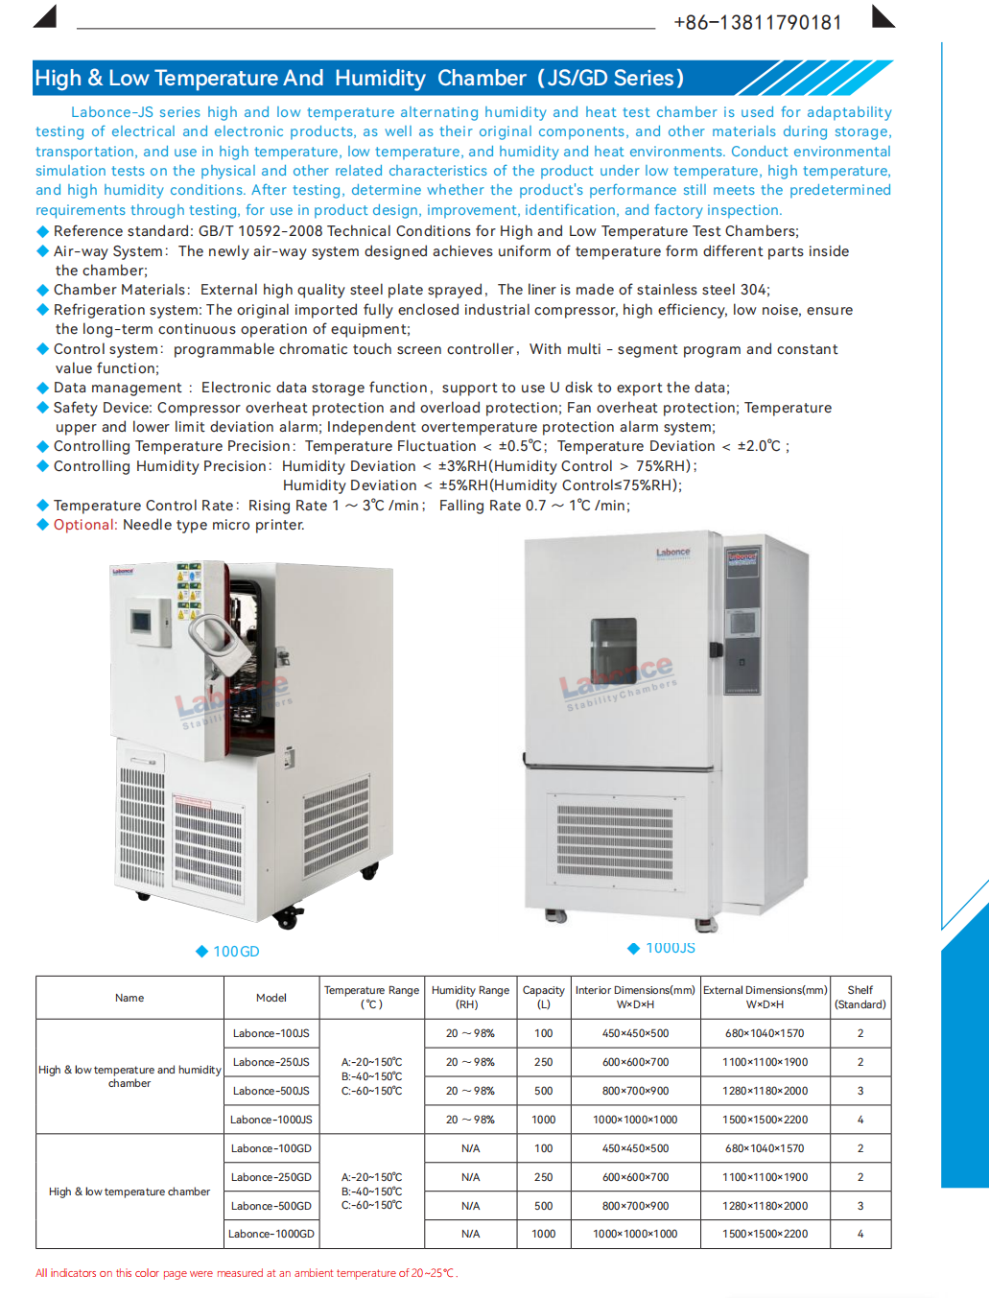
Equipment picture | 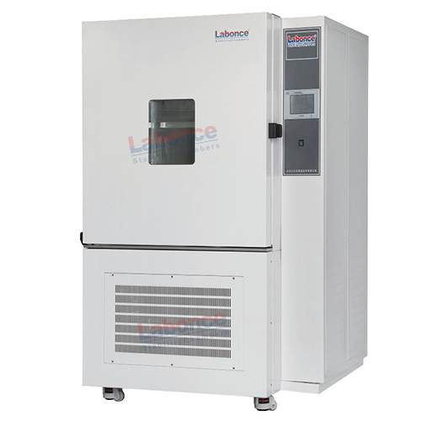
Water tank picture | 