Company ： JIANGSU LABONCE INSTRUMENT CO., LTD.
Address ：1F , 2F , NO.5 STANDARD FACTORY IN THE PIONEER PARK OF SMES, ECONOMIC DEVELOPMENT ZONE IN ZHENXING NORTH ROAD AND THE WEST OF WULING SOUTH ROAD , TAIZHOU CITY, JIANGSU PROVINCE, CHINA
Contact Person:Guston
Tel：+86-010-56545023 +86-13811790181
Fax ：010-56545070
E-mail ：export@labonce.com
Website：www.labonce.com

- Destination: | Within China
- Payment: | Negotiate
- Delivery Date: | 20-25 workdays
- Packing: | Wooden chamber package
- Freight age: | Within China
- Guarantee: | 1 year
- After-sale Service: | 24 hours online service
⑻ Others:
Our company is specialized in the research &development and production of temperature chambers. We adopted advanced Germany technology, reasonable structural design, and high-quality imported components, to supply stable, safe and reliable chambers.
1、Adopt the latest air duct system design, the temperature uniformity of different position inside the chamber is good；
2、Fully enclosed industrial compressor imported from Europe, high efficiency and low noise, ensure the long-term continuous operation of equipment；
3、European original imported temperature sensor, with high sensitivity, low annual drift, direct detection of without maintenance;
4、Special temperature controller, quick induction, small system error；
5、The liner material is full mirror stainless steel 304, easy to clean.

Description | Model | Unit | Quantity | FOB price（RMB） | Notes
Photo-stability Chamber | Labonce-150TPS-1 | set | 1
Photo-stability Chamber | Labonce-500TPS-2 | set | 1
Photo-stability Chamber | Labonce-500TPS-3 | set | 1
Photo-stability Chamber | Labonce-1000TPS-3 | set | 1
Total:

Technical Parameter：

Name | Photo-stability Chamber
Model | Labonce-150TPS-1 | Labonce-500TPS-2 | Labonce-500TPS-3 | Labonce-1000TPS-3
Temperature Range | 15~50℃
Accuracy | ±1.0℃
Deviation | ±2.0℃（Same layer）
Visible light range | 100 ~ 8000LUX
Total illumination | ≥ 1.2 x 10^6Lux·hr
UV range: NUV range | 0.84 ~ 5w/m squared
The near-UV energy | ≥ 200w•hr/㎡
UV wavelength: | Equipped with D65 light source,NVA wavelength: 320 ~ 400nm,1*independent light source system
Sensor | 1*Near UV sensor
Light Source Design | Top light source design
Chamber Material | The liner is made of mirror stainless steel 304
Refrigerating System | The imported fully enclosed industrial compressor, long-life, low noise.
Control System | Programmable color touch screen controller
Safety device | compressor overheat and overpressure overload protection, Fan overheat protection.
Dual Protection | Equipped with independent overtemperature protection system, can automatically cut off the power supply
Data Record | Equipped with data collection system conform to GMP requirements,Needle micro printer and USB output port as standard,Print and store a layer of illuminance values
Meet a criterion | Meet ICHQ1B、Chinese Pharmacopoeia 2020 edition
Ambient temp | ＋5～35℃
MAX power（kW) | 1.2 | 2.0 | 2.1 | 2.5
Capacity (L) | 150 | 500 | 500 | 1000
Interior dimensions  W×D×H (mm) | 650×490×500 | 660×680×1080 | 660×680×1080 | 1360×490×1360
External dimensions  W×D×H(mm) | 830×790×1250 | 860×1050×1850 | 860×1050×1850 | 1620×910×1990
Packing dimensions  W×D×H(mm) | 880×900×1380 | 1200×980×2060 | 1200×980×2060 | 1630×970×2150
GW | 150kg | 340kg | 340kg | 520kg

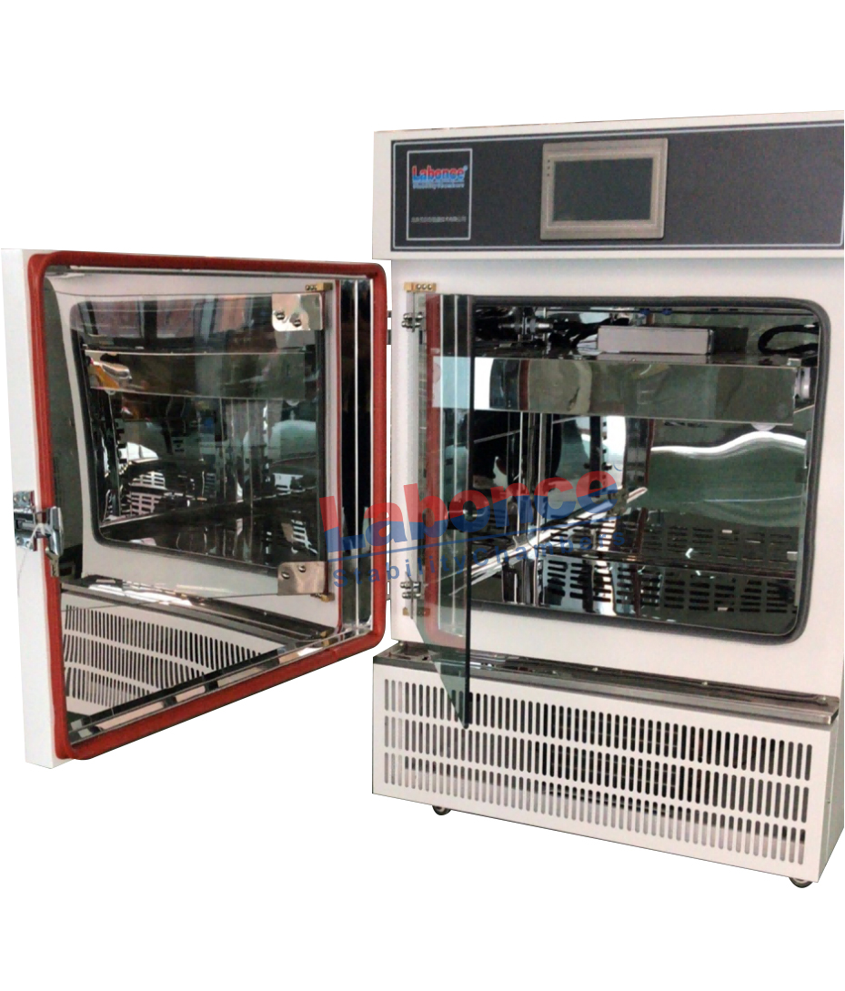

150L

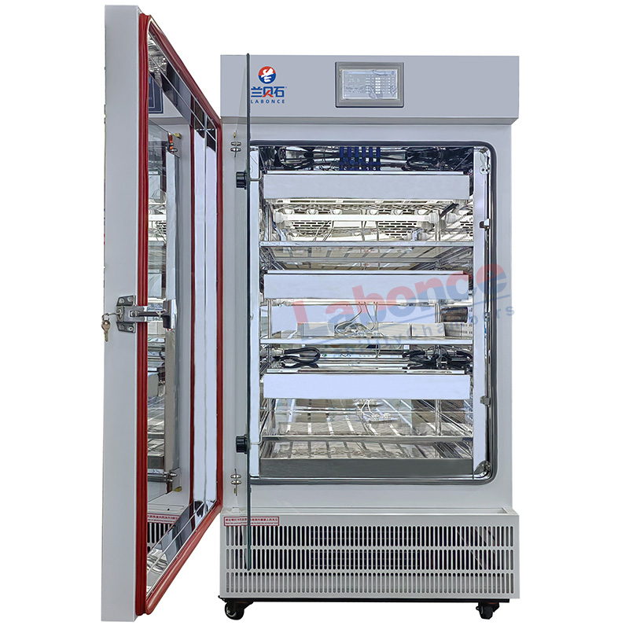

500L

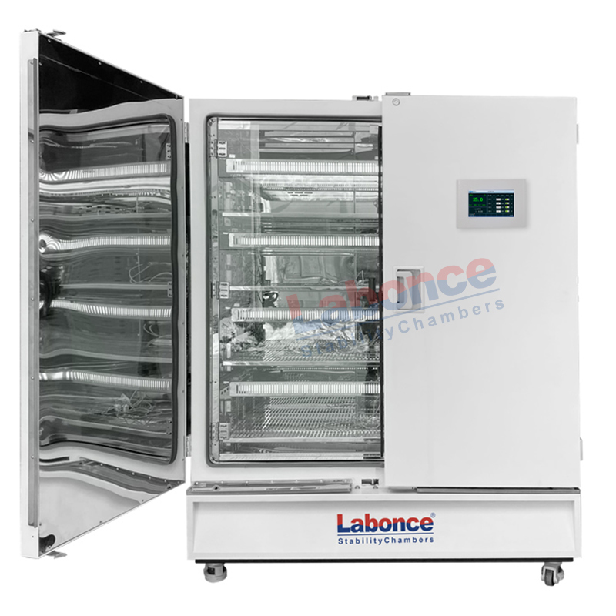

1000L

