Company ： JIANGSU LABONCE INSTRUMENT CO., LTD.
Address ：1F , 2F , NO.5 STANDARD FACTORY IN THE PIONEER PARK OF SMES, ECONOMIC DEVELOPMENT ZONE IN ZHENXING NORTH ROAD AND THE WEST OF WULING SOUTH ROAD , TAIZHOU CITY, JIANGSU PROVINCE, CHINA
Contact Person ：Cheney
Tel：+86-010-56545023 +86-13811790181
Fax ：010-56545070
E-mail ：export@labonce.com
Website：www.labonce.com

- Destination: | Within China
- Payment: | Negotiate
- DeliveryDate: | 25-30 workdays
- Packing: | Wooden box package
- Freightage: | Within China
- Guarantee: | 1 year
- After-sale Service: | 24 hours online service
⑻ Others: | T/T 100% payment
Our company is specialized in the research &development and production of stability chambers. We adopted advanced Germany technology, reasonable structural design, and high-quality imported components, to supply stable, safe and reliable chambers.
1、Adopt the latest air duct system design, the temperature and humidity uniformity of different position inside the chamber is good；
2、 Imported fully enclosed industrial compressor, high efficiency and low noise, ensure the long-term continuous operation of equipment；
3、European original imported temperature and humidity integrated sensor, with high sensitivity, low annual drift, direct detection of humidity without maintenance;
4、Imported temperature and humidity controller, quick induction, small system error；
5、Equipped with an alarm system that meets the requirements of GMP, a data collection system that meets the requirements of GMP, and a standard pin printer and U-Disk storage;
6、The liner material is full mirror stainless steel 304, easy to clean.
Description | Model | Unit | Qty | FOB price（USD） | Notes
Stability Chamber | Labonce-150GS-FC | set | 1 |  | Export wooden cases are packed to Shanghai port
Stability Chamber | Labonce-400GS-FC | set | 1 |  | Export wooden cases are packed to Shanghai port
Stability Chamber | Labonce-500GS-FC | set | 1 |  | Export wooden cases are packed to Shanghai port
Total:

Technical Parameter：
Name | Stability Chamber
Model | Labonce-150GS-FC | Labonce-400GS-FC | Labonce-500GS-FC
Temperature Range | 10～65℃
Accuracy | ±0.5℃
Deviation | ±1.0℃
Humidity Range | 20～95%RH
Deviation | ±3%RH
Control Manner | Temperature and humidity balance Control
Refrigeration System | Imported inverter type fully enclosed compressor, power saving 50%, water saving 80%, heat dissipation halved
Humidity Sensor | Imported capacitive humidity sensor high precision, no need for regular maintenance
Controller | Imported Touch screen Temperature and humidity controller,With three levels of user authority, audit tracking function.The frequency conversion output ratio is directly displayed on the control interface
Data Record | Micro Printer with needle type
Data Copy | Flash memory with U-disk
Deviation | High&low boundary deviation alarm for temperature&humidity
Dual protections | Independent overheat protection warning system
Ambient temp | ＋5～35℃
Interior material | Mirror surface Stainless steel 304
External material | Steel powder coated
Water tank | External Water Tank
Power source | AC 220V±10% 50Hzor60HZ
Dual door | Glass door inside
Safety device | Compressor overheating, fan overheating, overtemperature, compressor overpressure, overload, water shortage protection
MAX power （kW） | 1.2 | 2.0 | 2.2
Capacity (L) | 150 | 400 | 500
Interior dimensions  W×D×H (mm) | 600×405×620 | 600×700×950 | 680×680×1080
External dimensions  W×D×H(mm) | 780×830×1480 | 780×1060×1750 | 860×1050×1850
Packing dimensions  W×D×H(mm) | 870×850×1570 | 850x1080x1980 | 930×1140×2040
Trays (standard) | 3 | 3 | 4
Gross Weight(KG) | 185 | 250 | 300

Catalog
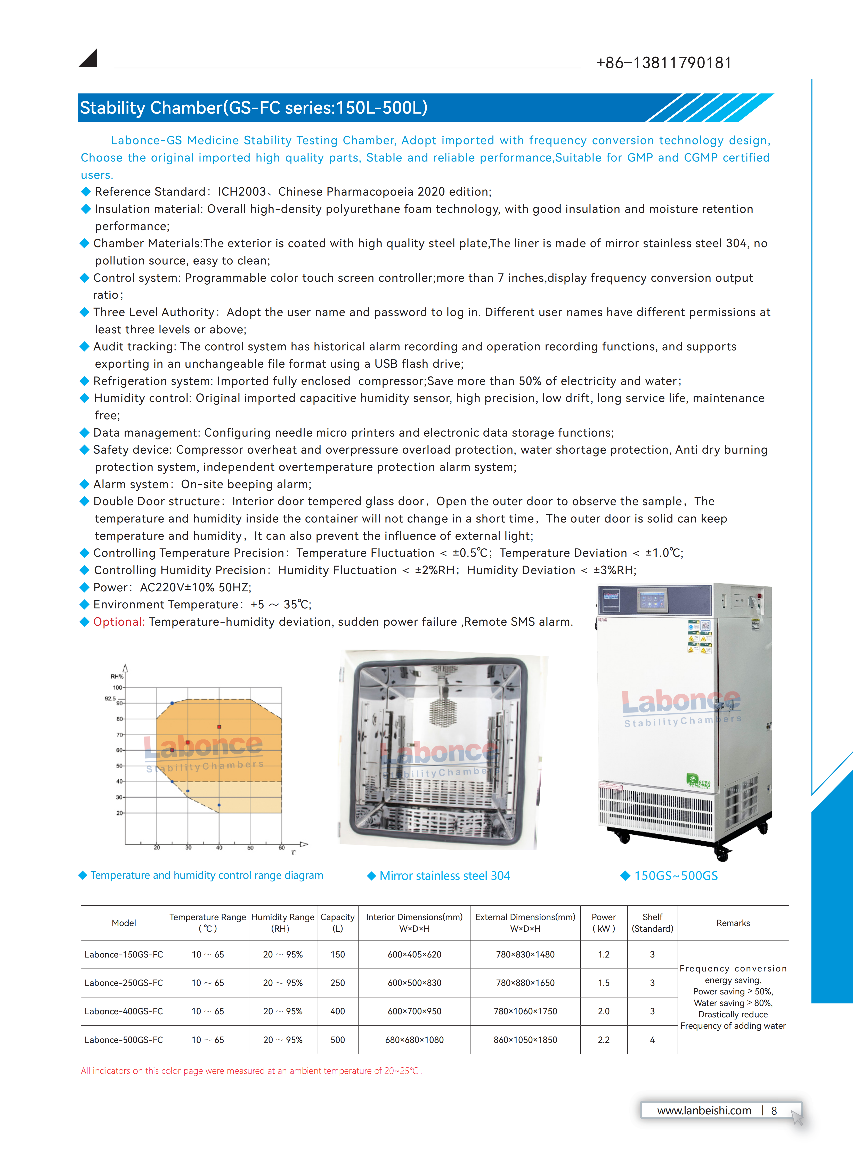

Equipment picture | 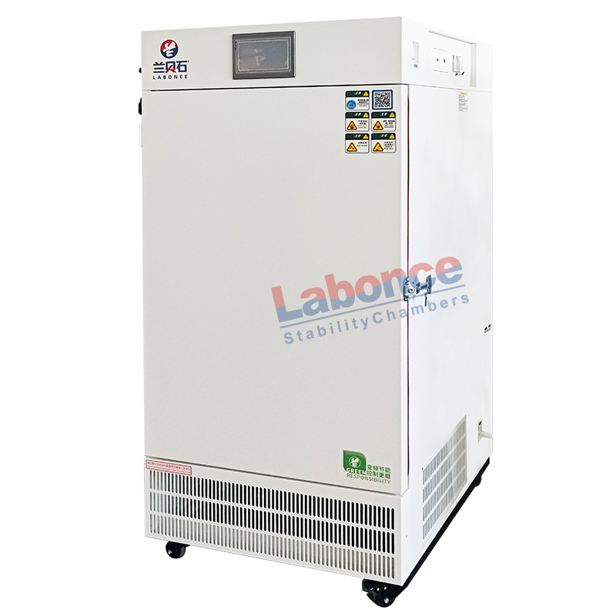
Dimensional drawing | 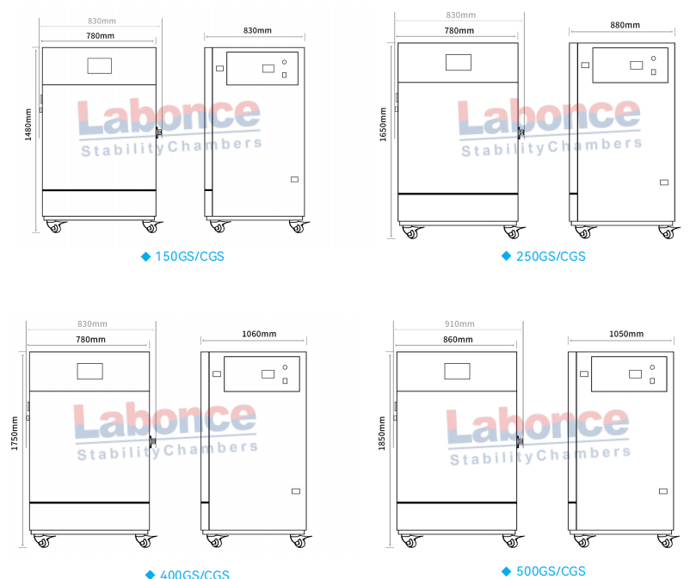
Water tank picture | 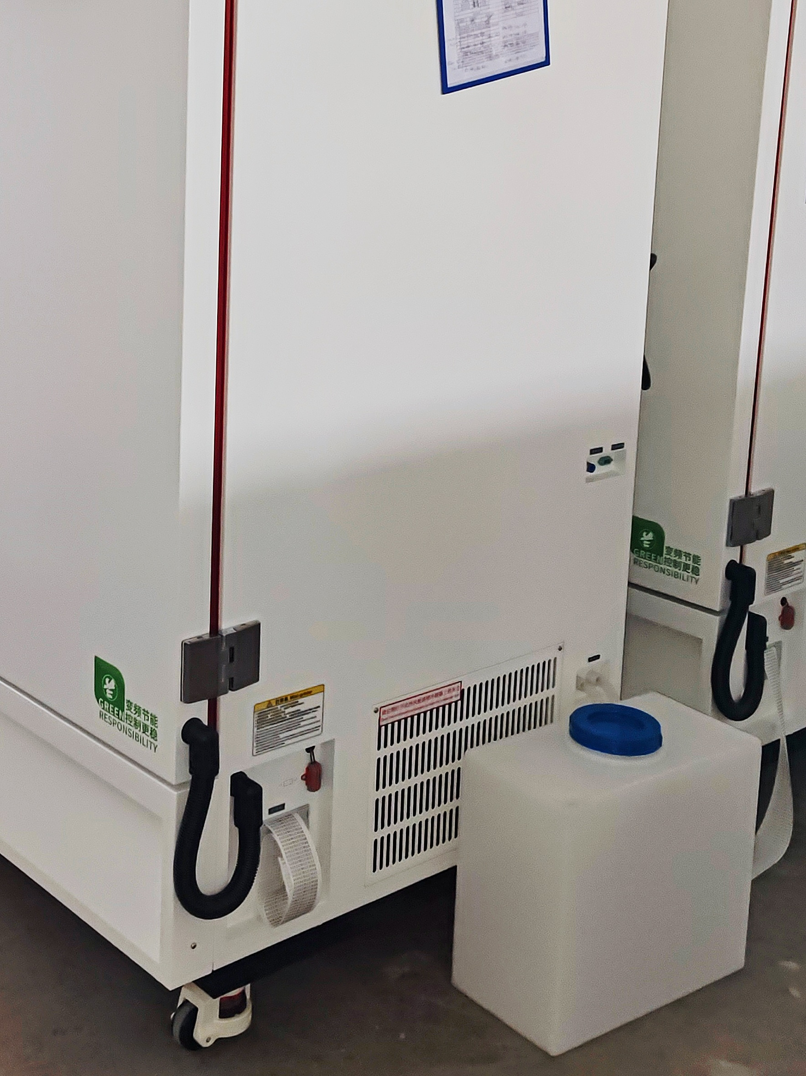
Temperature and humidity range diagram | 